TITLE OF THE CONTRIBUTION (bold capital letters, 14pt)

Author A¹, Author B², Author C³ (12pt, underline the corresponding author)

¹Institution 1(TNR 12pt centred)
²Institution 2 (TNR 12pt centred)
³Institution 3 (TNR 12pt centred)

E-mail (corresponding author)

- INTRODUCTION (Bold, 12pt)
This template is meant to be used for the submission of accepted contributions. The template has been prepared using the format required for any submissions to the symposium. Accepted authors of oral presentations are invited to submit a full paper (maximum 12 pages, including references) by May 30th, 2026. Accepted authors of poster presentations do not need to submit a full paper, but they can submit an updated version of the extended abstract (up to 4 pages of length, including references) in .pdf format and should not exceed 5 MB. The submission should be done via email to mail@humanbehaviourinfires.se with a deadline on the 30th of May 2026 at 16:00 CET.

Contribution: The authors are encouraged to include introduction, methods, results and discussion, conclusion and references, but they can also structure the proceeding contribution in different ways. The contribution should be prepared on an A4-sized paper with 25 mm margins on all sides and typed with single spacing using size 12 Times New Roman font. All illustrations must be prepared inside of the main text (no appendices are allowed).

- METHODS (Bold, 12pt)
The methods must be clearly stated and described in sufficient detail or with sufficient references.

- RESULTS AND DISCUSSION (Bold, 12pt)
The findings of the work should be described and discussed. Supporting figures, tables or images can be used as well. Figures and images should be numbered and figure headers should be placed under the figure or image; as for the tables, they should also be numbered and the table header should be placed at the top.

- CONCLUSION (Bold, 12pt)
Conclusions should include the principles and generalisations inferred from the results and theoretical and/or practical implications of the work.

4.1. Equations
Equations should be centred and numbered consecutively, as in Eq. [1].
(1 line spacing here)

a_{b} = q²l_{i}/(kρb (A_{p} - A_{i}))⁴ [1]

  - Tables and figures
Tables and figures should be numbered consecutively. Figures and tables should have a centred caption directly beneath the figure or above a table. Tables should follow the style shown in Table 1. Table captions should be in Italic 12pt “Time News Roman”, centred, and the texts in Table should be set in 12pt “Time News Roman” font.

Table 1. Caption heading for a table should be placed at the top of the table.
 | A | B | C | D
A | Aa | Ab | Ac | Ad
B | Ba | Bb | Bc | Bd
C | Ca | Cb | Cc | Cd
D | Da | Db | Dc | Dd
E | Ea | Eb | Ec | Ed

You can use coloured graphs, plots and photographs. Figure 1 shows one example. Figure captions should be in 12pt “Time News Roman” font, italic, centred. When applicable, the texts in graphs, illustrations or images should be set to at least in 8pt.

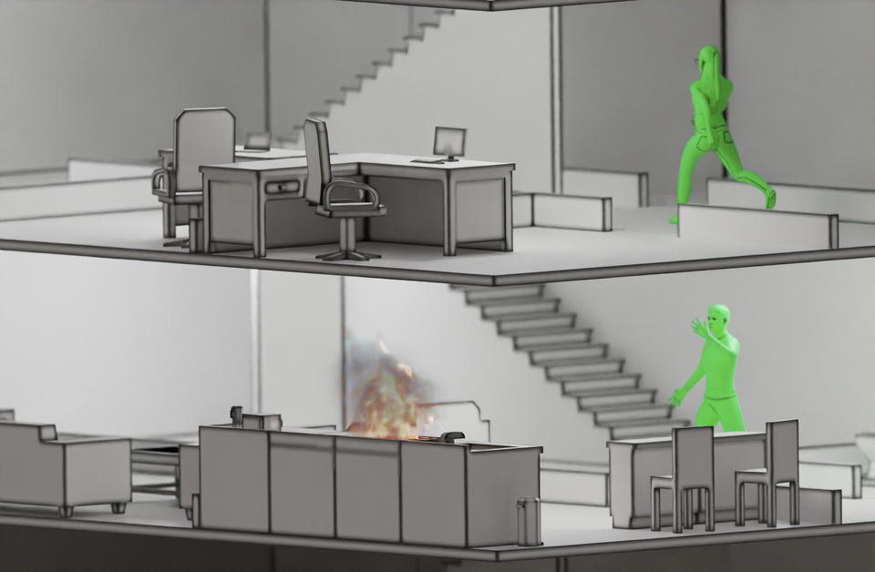
Figure 1. The caption for a figure should be placed below the figure and should be centred. (Use Italic “Time News Roman” font, size 12pt, no spacing between title and figure)

  - Units
Use SI as primary units. Imperial units may be used as secondary units (in parentheses).

REFERENCES
References should be listed in alphabetical order following the American Psychological Association Style (APA 7th Edition), as in this example (Ronchi et al., 2025).

Ronchi, E., Ronkisson, H., & Ronchis, K. (2025). Example of reference according to the American Psychological Association Style (APA style 7th Edition). Journal of Inexistent Research, 1(1), 54–65.

